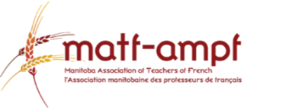
Professional Development for All

The Manitoba Association of Teachers of French is pleased to offer a free professional development opportunity specific to rural teachers of French Communication and Culture. This professional development day will not only allow teachers to learn engaging ways to teach FCC but also allow them to collaborate with other rural teachers from surrounding school divisions. MATF will be covering the sub costs for the first 15 MATF members to register. Registration is free for MATF members*. Registration information and agenda of the day are included below.

When: Friday, April 13, 2018
9:00 am- 3:30 pm
Lunch Catered by Pizza Haven
Where: Borderland SD Board Office
120 9th Street NW Altona, MB

How to Make French in Your Classroom Fun, Hands-on and Authentic!
Presented by Carling Comte and Sarah Barton
9:00-11:45- Games, activities and routines for the French classroom. Activities follow the themes and guidelines indicated in the Manitoba French Communication and Culture Curriculum. Have fun while teaching French as your students learn in hands-on ways. Suitable for grades 4 to 12.
11:45-1:00 Lunch

1:00-3:30- Examine and experience an entire unit on “Le Corps, Accessoires et
Vêtements”. You will learn and explore various teaching styles, activities and student-facilitated games that will allow every student to be successful and enjoy their French learning. The unit outlined follows themes and guidelines indicated in the Manitoba French Communication and Culture curriculum. Suitable for grades 4 to 12.

To register, please e-mail Lucie Boutet at luboutet12@gmail.com. She will contact you to confirm your registration and notify you if you are one of the first 15 teachers to register.
*If not already a member, go to www.matf.ca to purchase membership for $35.

Funded in part by French Second Language Revitalization

