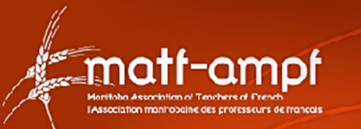
2019 Greg Sametz Award Winner
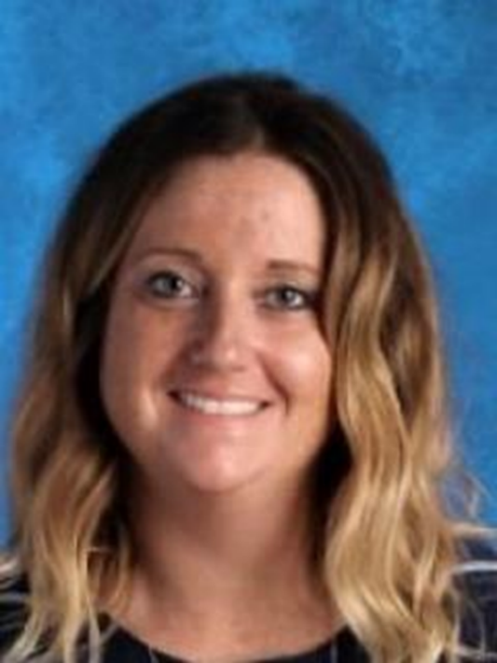
Carling Comte

Carling has been a part of the learning community at Niverville Middle School since 2015 and has made significant and valuable contributions in the area of French language learning for both our students and teachers.
Immediately upon her arrival, Carling worked very hard to reverse the stigma associated with learning French by integrating fun and engaging practices into each of her French classes. Not only did her students benefit but teachers benefited as well as she was willing to share any and all resources with both school staff and divisional staff at our annual divisional PD where she runs sessions. Within her school, Carling has started a weekly French club and an annual French is Fun festival which includes carnival style games led by the 8th grade French students and enjoyed by our grade 5-7 students. Carling brings together our entire school community for this day and takes on all the organization to ensure this day runs smoothly.
Carling is also active in supporting both new and experienced French teachers through professional development. Carling has given much of her time and energy to the planning and implementing of sessions for both the MATF collaboration and rural PD programs as well as presented at multiple MTS PD days.
As educators who has benefitted on numerous occasions from Carling’s mentorship in teaching French, we believe she is extremely deserving of this award. It is very evident that her students learn to love French because Carling loves French. Her enthusiasm and passion for teaching the language is exemplified daily and it is our hope that by receiving this award Carling will know that her contributions are valued by the French education community.

